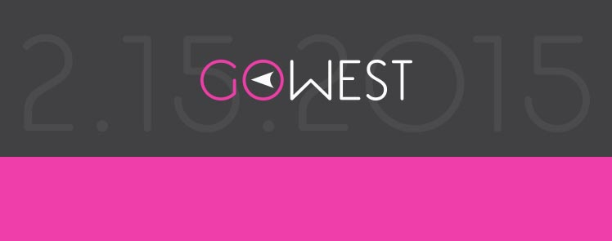

A BENEFIT FOR KRIS WEST AND HER FAMILY TO HELP BEAT BREAST CANCER
Join Kris and her family for food, fun and fundraising!

Sunday, February 15, 2015
1:00 to 5:00 pm

Live Music
by

Two Hicks and a Chick

Food ~ Cash Bar

Silent Auction and Raffle
Silent auction closing at 3:30 pm

Medina Entertainment Center
500 Highway 55, Medina, MN 55340

$10 suggested donation at the door
cash or check preferred

More details: www.facebook.com/gowest2152015
Questions: email: gowest.2.15.2015@gmail.com or call 952-996-9657

